Episode 509: Radioactive background and detectors

This episode introduces the ubiquitous nature of radioactivity, and considers its detection. It draws on students’ previous knowledge, and emphasizes the importance of technical terminology.
Lesson Summary
- Demonstration: Detecting background radiation (10 minutes)
- Discussion: Sources of background radiation (15 minutes)
- Demonstration: Radioactive dust (10 minutes)
- Discussion and survey: Sources of radiation – should we worry? (15 minutes)
- Demonstration and discussion: Am-241 source, plus use of correct vocabulary (10 minutes)
- Demonstration: Spark detector (10 minutes)
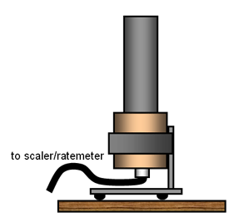

Demonstration: Detecting background radiation
Use a Geiger counter to reveal the background radiation in the laboratory. What is the signal like? (It is discrete, erratic / random.) Does it vary from place to place in the room? (No; it may appear to; this is an opportunity to discuss the need to make multiple or longer-term measurements.) Does it vary from time to time? (No, it’s roughly constant.)
Count for 30 s to get a total count N ; repeat several times to show random variation. Calculate the average value of N.
(Note: a good rule of thumb is that the standard deviation is
√ N _{ave} , so roughly two-thirds of values of N will be within ± √ N _{ave}.)
Which is better: 10 counts of 30 s, averaged to get the activity, or one count of 300 s? (They amount to the same thing. The statistics of this is probably beyond most post-16 level students.)
Calculate the background count rate from the data (typical value is 0.5 counts per second or 30 counts per minute, but this varies a lot geographically.)
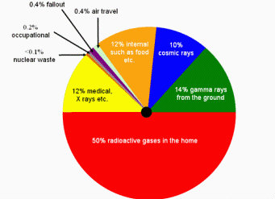

Discussion: Sources of background radiation
Look at charts showing sources of background radiation. Consider how these might vary geographically, with time, occupation etc.
Pie chart for background radiations
Note that pie charts in text books etc showing relative contributions are often calibrated in units of equivalent dose of radiation called sieverts (symbol Sv); sievert is a unit which takes account of the effects of different types of radiation on the human body.
1 Sv = 1 J kg⁻¹
(1 J kg⁻¹ = 1 m² s⁻²)
Episode 509-1: Doses (Word, 40 KB) - see end of document

Episode 509-2: Whole body dose equivalents (Word, 40 KB) - see end of document

Demonstration: Radioactive dust
Airborne radioactive substances are attracted to traditional computer and TV screens that use a high voltage. Similarly a charged balloon will also accumulate radioactive dust and have an activity larger than the average background. The fresh dust in vacuum cleaner bags has a noticeably higher activity too.
Set up a Geiger counter to measure the activity of vacuum cleaner dust; don’t forget to measure background rate also.
Episode 509-3: Radiation in dust (Word, 29 KB) - see end of document

Discussion and survey: Sources of radiation – should we worry?
So radiation is all around us. Indeed, most substances, and things, are radioactive. Students are radioactive! Typically 7000 Bq. So it’s dangerous to sleep with somebody! However, most of the resulting radiation is absorbed within the owners body.
Introduce activity of a sample as a quantity, measured in becquerels (Bq). Mass of a typical student is 70 kg, so
specific activity = 7000 Bq70 kg
specific activity = 100 Bq kg⁻¹.
The Radiation Protection Division of the Health Protection Agency (formerly the National Radiological Protection Board, NRPB) defines a radioactive substance as having specific activity 400 Bq kg⁻¹.
Should we worry about this? Ask students to complete this survey, and then re-visit at the end of the topic. For each statement, indicate whether they think it is true or false, or they don’t know.
S1: Radioactive substances make everything near to them radioactive.
S2: Once something has become radioactive, there is nothing you can do about it.
S3: Some radioactive substances are more dangerous than others.
S4: Radioactive means giving off radio-waves.
S5: Saying that a radioactive substance has a half life of three days means any produced now will all be gone in six days.

Discussion and demonstrations: Am-241 source, plus use of correct vocabulary
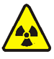

Radioactive sources
Follow the local rules for using radioactive sources, in particular do not handle radioactive sources without a tool or place them in close proximity to your body.
Place an Am-241 source close to the GM tube and measure the count rate, which will be impressive, compared to background. (Some end window GM tubes will not detect alpha emission from AM-241 but only weak gamma).
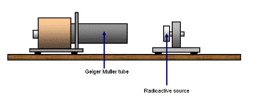
From here on, start to use appropriate technical vocabulary, drawing on students’ earlier experience. For example: Substances are radioactive, they emit radiation when they decay. Why are some substances radioactive? (They contain unstable nuclei inside their respective atoms.) The unstable nucleus is called the mother and when it (she?) decays a daughter nucleus is produced (it’s not quite like human procreation!).
Eventually the activity of a radioactive substance must cease. However, point out that the decay of the americium doesn’t seem to be getting any less. There are a very large number of nuclei in there!
Am-241 is used in smoke alarms, so it won’t run out. They are supplied with 33.3 kBq sources. The half-life is 458 year.
What particular property does nuclear radiation have – what does it do to the matter through which it passes? (It is ionizing radiation. It creates ions when it interacts with atoms.) What is an ion? (A neutral atom which has lost or gained (at least one) electron.)

Simplified diagram of a smoke alarm
To knock an electron from an atom, the ionizing radiation transfers energy to the atom – this is how nuclear radiation is detected. It is not difficult to detect the presence of a single ion – electron pair, so it’s easy to detect the decay of single radioactive nucleus. Chemists can detect microgrammes or nanogrammes of chemical substances, physicists can detect individual atomic events.
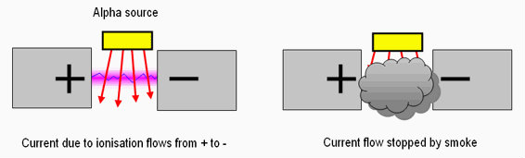

Demonstration: Spark detector
Show a spark detector responding to the proximity of an alpha source. (NB At first, do not refer to the source as an alpha source.) Move the source away a few centimetres; you do not need much distance in air to absorb this radiation. Ask students to recall which type of radiation is easily absorbed by air. (Alpha.)
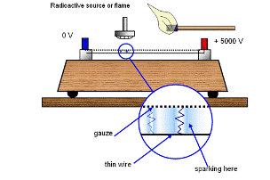
Episode 509-4: Rays make ions (Word, 82 KB) - see end of document

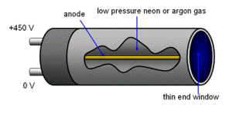
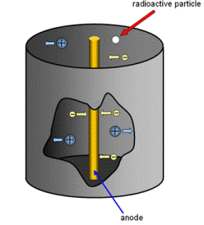
Comment that a GM tube is not dissimilar to a spark counter, but rolled up to have cylindrical symmetry. At this point, you could discuss the sophisticated design of a GM tube and associated counter. The end window is usually made of mica and has a plastic cover, with holes, to protect the mica.
Episode 509-1: Doses

Practical advice
This gives a simple view of the connection between gray and sievert as units of radiation dose measurements.
It may be best to change the size of the diagram and use it as an OHT.

External reference
This activity is taken from Advancing Physics chapter 18, display material 20O

Episode 509-2: Whole body dose equivalents

Practical advice
This shows the breakdown of whole body doses, from different sources.
It may be best to change the size of the diagram and use it as an OHT.

External reference
This activity is taken from Advancing Physics chapter 18, display material 30O.

Episode 509-3: Radiation in dust

Ionisation in the home
Radon gas is present in the atmosphere of our homes; its daughter products can contribute to the background count as constituents of household dust. In this activity you are asked to collect dust and assess its level of radioactivity.
You will need
- two sheets of kitchen paper towel
- radiation sensor, alpha sensitive (NB not a standard GM tube)
- stop watch
- rubber band

What to do
1. Collect some household dust on a sheet of kitchen paper towel. One way to do this is to cover your finger with the paper and then to wipe your finger over the surface of a dusty television or computer monitor screen. Do this for the whole screen, more than one screen if possible – you need a substantial layer of dust. Put the paper carefully to one side. Do not dislodge the dirt. (Incidentally, one reason for suggesting the dust from a television screen is because it is charged. It therefore attracts the ionised daughter products from, amongst other things, radon decays.)
2. Take a new clean piece of identical kitchen paper. Fix it around the thin window end of the sensor using a rubber band. Take a background measurement for a substantial time, several thousand seconds or even overnight if possible. Automating the capture of the data will prove useful.
3. Without changing any other conditions replace the clean paper with the dusty paper. Wrap it around the GM tube with the dust fingerprint side next to the window so that alpha particles are not absorbed by the paper. Take care not to get the dust onto the sensor.
4. Measure the radioactive count from the dust for the same length of time as before.
5. Look critically at the results. Are they significantly different? Remember that variation in a radiation experiment is equal to the square root of the measurement itself. Do the two results differ by substantially more than this?

You have
Measured some of the ambient radiation from a household.

Practical advice
This experiment needs care but it does yield interesting results. It requires long timings and not a little luck. Household dust has radioactive products from a number of decays.
In trials a count for 600 s produced the following results: background count (no paper): about 230 counts; background count (with paper): about 240 counts; dust count: about 295 counts. There was a substantial amount of dust on the paper from three computer monitors.

Alternative approaches
The use of TASTRAK plastic is a possible substitute here.
The plastic known as CR-39 was developed in 1933 and in 1978 it was found to be an excellent detector of charged particles, which could be revealed by etching the plastic. TASTRAK is a version of CR-39 developed specifically to detect alpha particle tracks. It can be used to demonstrate the detection of radon.
The suppliers, TASL, offer kits of TASTRAK plastic for class use which may then be returned to the Track Analysis Group for processing free of charge. This arrangement is STRICTLY for UK schools, colleges and universities only.
Track Analysis Systems operate a free etching service. It is not recommended that you attempt the etching process yourself. When returning the exposed slides, remember to declare whether you require them to be in microscope or slide projector form.
You can find more information about TASTRAK from http://www.tasl.co.uk/schools.htm or Track Analysis Systems Ltd, H H Wills Physics Laboratory, Tyndall Avenue, Bristol. BS8 1TL, U.K.
Tel: +44 (0)117 926 0353, Fax: +44 (0)117 925 172
Be safe
Students should wash their hands before eating after collecting the dust.

External references
This activity is taken from Advancing Physics chapter 18, activity 20H.

Episode 509- 4: Rays make ions

The particles and rays that come from radioactive (unstable) nuclei are known generically as ionising radiation. Ionising radiations do just what their name says – they ionise atoms by removing one or more of the electrons outside the nucleus. It is this property that helps us to detect the radiations in many of the instruments that may already be familiar to you.
In this activity you will learn to use a simple detector of ionising radiation – the spark detector.
You will need
- spark counter
- EHT power supply, 0 – 5 kV, dc
- leads
- almost pure alpha source (The only ‘pure’ alpha source available in schools is Pu-239. Am-241 emits gammas too. However, since the spark counter only responds to the alphas, any alpha-emitting source will do here)
- forceps or tweezers for handling the radioactive source (or source holder)
Radioactive sources
Follow the local rules for using radioactive sources, in particular do
not handle radioactive sources without a tool or place them in close
proximity to your body.

Ionisation and its effects
First, some ideas about ionisation and its effects.
Ionisation is the name given to the process in which an atom or molecule gains or loses one or more electrons. In the detection of radioactivity we are normally concerned with the loss of an electron. The mechanism is that radiation is emitted from an unstable nucleus; the particle or ray carries energy away with it. It is this loss of energy that allows the radioactive atom to become more stable. As the particle moves away through the air or a more dense substance it comes close to atoms, sometimes sufficiently close to interact. The particle can simply bounce off the atom – an elastic collision – or it can interact inelastically and transfer some its energy to the atom. This gain of energy by the atom leads to the removal of one of its electrons. You can think of the particle or ray as having knocked the electron free of its atom. Energy taken from the incoming particle or ray is needed for this to occur.
Can you think of examples in which ionisation is used to detect radiation?

Getting going
1. Now, before setting it up, look closely at the spark detector. You should be able to see a grid or array of very fine wires running parallel and close to the surface of a metal plate or above a wire. There may also be an arrangement for holding a radioactive source a fixed distance from the wire array. Your power supply will maintain a high potential difference between the plate and the wires. There will be a large electric field in the space between the wires and the plate.

Wire carefully, EHT supply I use
Although school EHT supplies are current-limited and safe, using the extra limiting resister (50 MΩ) reduces the shock current to a trivial level.

2. Now connect up the detector to the power supply. Ask for help if you are not certain how to do this. To be safe the wires (the part you are most likely to touch) should be at earth (0 V) potential. Adjust the EHT until sparks just pass, then reduce it slightly.
3. Insert a source of alpha particles into the holder and ensure that the source is pointing towards the wire array and about 10 mm from it. Take the usual handling precautions with the source.

4. Does an increase in the potential difference make a significant change in the sparking rate?
The alpha particles ionise the air molecules as they travel from the source. The sparking is a result of what happens when the ionisation occurs in the strong electric field produced by the spark detector. Look at the diagram.
The field is directed between the wire and the gauze, or between the wires and the plate. So, once the electron and its ion (the original atom) are separated, the electron moves towards the wire and the ion moves towards the plate. The ion has a large mass and so gains speed slowly. The electron, however, has a low mass so its acceleration is large. (You might want to estimate how large it is: to do this use the distance from wire to plate and the voltage setting to make a reasonable estimate of the electric field strength, hence the force and the acceleration.)
If an electron can gain enough energy from the field it will be able to collide with another gas atom and cause a further ionisation. So one electron has now produced two: the original one plus the one from this second ionisation. Both of these can go on to accelerate and ionise again. The number of electrons in the space builds up rapidly and eventually the air contains enough electrons in one region to allow a spark to jump from wire to plate. This is known as a cascade process.

You have seen that
1. Radioactive particles are often detected using ionisation. Examples include the spark detector, the Geiger–Müller tube, the cloud and bubble chambers, and photographic detection methods.
2. Such methods show us where the particles have caused ionisation. They are not direct detections of the particles themselves.
3. Some methods rely on a cascade process in which ions are multiplied by successive ionisations in a strong electric field.

Also try

TAP 519: Particle Detectors
Practical advice
Students may need close supervision in using this apparatus. They will also need guidance in the correct earth setting to avoid electric shock. The instructions provided in the activity may need to be altered to suit the style of spark detector you have.

Radioactive sources
Follow the local rules for using radioactive sources, in particular do
not handle radioactive sources without a tool or place them in close
proximity to your body.

Wire carefully, EHT supply in use

Social and human context
Every time your teeth are x-rayed, ionisation processes are used to expose the film. The ubiquitous Geiger–Müller tube involves a controlled cascade between the central wire and the outer cylinder inside the tube. We rely heavily on the ionising effects of radiation for its detection.

External reference
This activity is taken from Advancing Physics chapter 18 activity 50E

